Experiment-6
Program:
import cv2
import numpy as np
# Step 1: Read the image
image = cv2.imread("image.jpg") # Replace with your image path
# Check if image loaded properly
if image is None:
print("Error: Image not found!")
exit()
# Step 2: Convert to Grayscale (optional but common for morphology)
gray_image = cv2.cvtColor(image, cv2.COLOR_BGR2GRAY)
# Step 3: Create a kernel (structuring element)
kernel = np.ones((5,5), np.uint8) # 5x5 kernel
# Step 4: Apply Erosion
eroded_image = cv2.erode(gray_image, kernel, iterations=1)
# Step 5: Display images
cv2.imshow("Original Image", image)
cv2.imshow("Grayscale Image", gray_image)
cv2.imshow("Eroded Image", eroded_image)
# Wait until a key is pressed
cv2.waitKey(0)
cv2.destroyAllWindows()
# Optional: Save the eroded image
cv2.imwrite("eroded_output.jpg", eroded_image)

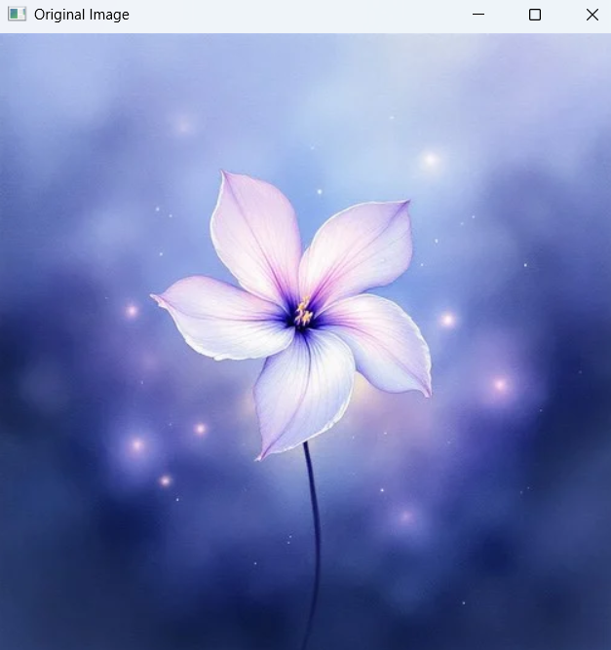
Input:

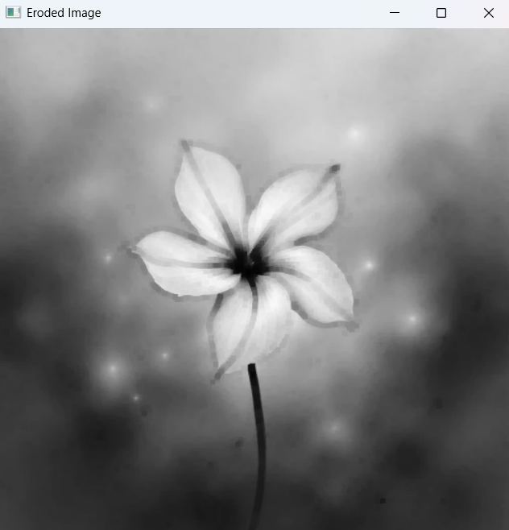
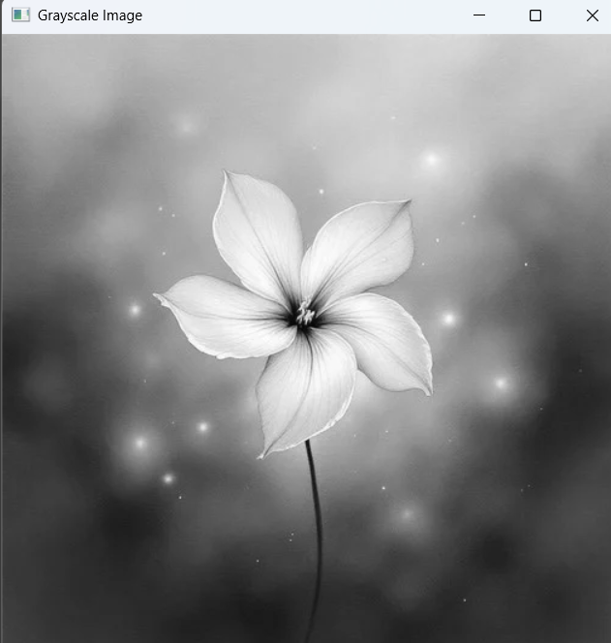
Output:

